**Electronics**

**Edf motor**

**DS-51-DIA HST ® with DSM4341-1050**

Inner jacket diameter: 93 mm  
Geometric throughput area: 51 cm²  
Total weight: 640 g  
Stand thrust range: 53-76 N  
Beam speed: 93-111 m / s  
Speed ​​range: 33,100-39,400  
Input power: 3.5-6.0 kW  
Battery: 10-12S 6000 mAh  
Efficiency: 70-71 %

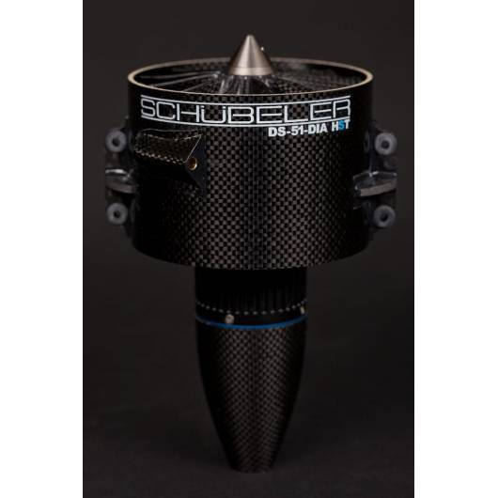

|  |  |
| --- | --- |
|  |  |
|  |  |

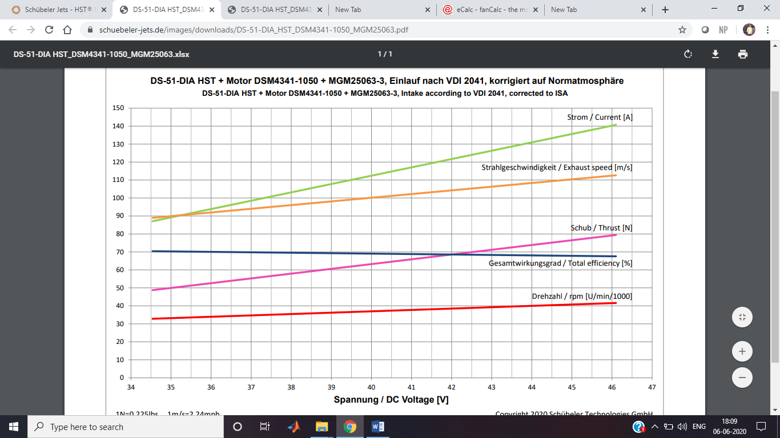

**Battery**

There are two motors

Each motor is connected to 2 batteries of 6000mAh 25 c 6s in series.

The nominal voltage produce by the pair of batteries are 44.4v and they discharge rate is 150A

The plane needs 2 pairs of batteries in series.Hence a total of 4 batteries

**Turnigy nano-tech 6000mah 6S 25~50C Lipo Pack**

Number of turnigy batteries needed=4

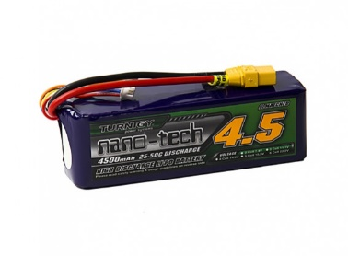

Capacity: **6000mAh**  
Voltage: **6S1P / 6Cell / 22.2V**  
Discharge: **25C Constant / 50C Burst**  
Weight: **908g (including wire, plug & case)**  
Dimensions: **167x49x55mm**  
Balance Plug: **JST-XH**  
Discharge Plug: **4mm Bullet-connector**

Suited to the following models: **MIKADO LOGO500/500SE, ALIGN T-REX600**

**Total area=(167x49x55mm3)x4=1800260mm3=1800.260cm3**

Reason for choosing this battery

* Capacity is 6000mAh
* The volume occupied by this battery is the least when compared to other models
* Bullet connectors are preferred as the current drawn by the esc is 150A.It is perfect for high amp applications. Also protects against reverse polarity connections

Battery required for the transmitter:  
 2600 mAh LiPo Transmitter Battery: DX18

Number of 2600mAh Lipo batteries required is 1

**ESC**

**Jeti Mezon Lite 130 12S Brushless ESC w/Telemetry**

No of esc’s needed is 2

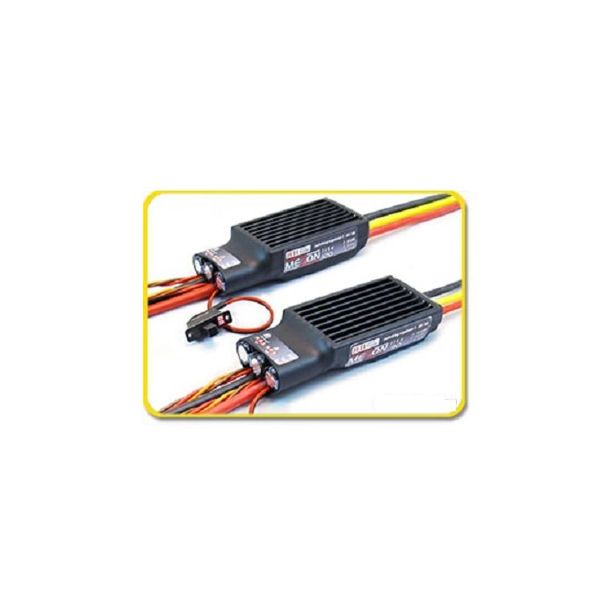

|  |  |
| --- | --- |
| **ESC** | **Jeti Mezon 130 Lite** |
| **Manufacturer** | Jeti |
| **Applications** | Heli/Airplanes/Sailplanes |
| **Special Features** | Data Logging, Telemetry |
| **Cont/Max Amp** | 130/300A |
| **Cells NiMH/NiCD** | 6-40 cells |
| **Cells Li-poly** | 2-12 cells |
| **Voltage** | 5-51V |
| **Programming** | JetiBox, JetiBox Profi, PC |
| **BEC Type/Max (A)** | Switching/8A |
| **Max #Servos/V** | 7-10/5-8V |
| **Dimensions** | 90mm x 37mm x 22mm |
| **Weight** | 140g |
| **SBEC** | 5v-8v |

**The brand new line of Jeti MEZON ESCs target mainly professionals and pilots looking for uncompromised precision and quality. The MEZON ESCs combine new revolutionary design with Jeti's state of the art manufacturing capabilities.**  
  
Jeti MEZON ESC's advanced design and software are capable of unmatched precision and efficient motor management. With DUPLEX integration all data is measured in real time. Mezon ESCs were designed with a revolutionary BEC circuit capable measuring the exact battery capacity used and lets you set up a motor cut off point based not only on cell voltage but also on overall battery pack capacity. This function, combined with Jeti DUPLEX system, offers you full telemetry capabilities with the possibility of saving your data for further analysis.  
  
**Advanced Helicopter features include governor with Active Free Wheel and Fast Response mode.**

**Reasons for choosing this esc**

* this esc is rated 130A
* It has a built in SBEC which has almost zero the energy lost in terms of heat **.**Also prevents the motor from overheating.while BECs have a lot energy loss interms of heat energy.
* It has a low voltage cutoff preventing the voltage to go below 3v per cell.If the voltage in alipo battery goes below 3v per cell then it leads to permanent degradation of the lipo battery to hold charge
* Has a max voltage of 51v.As the battery choosen is 12s which has a max voltage of 50.4V.

**Servo motor:**

**A total of 7 servo motors are required**

* **2 servos for ailerons**
* **1 servos for rudder**
* **1 servo for elevators**
* **2 servos for folding wing mechanism**
* **1 servo for ball dropping mechanism**
* 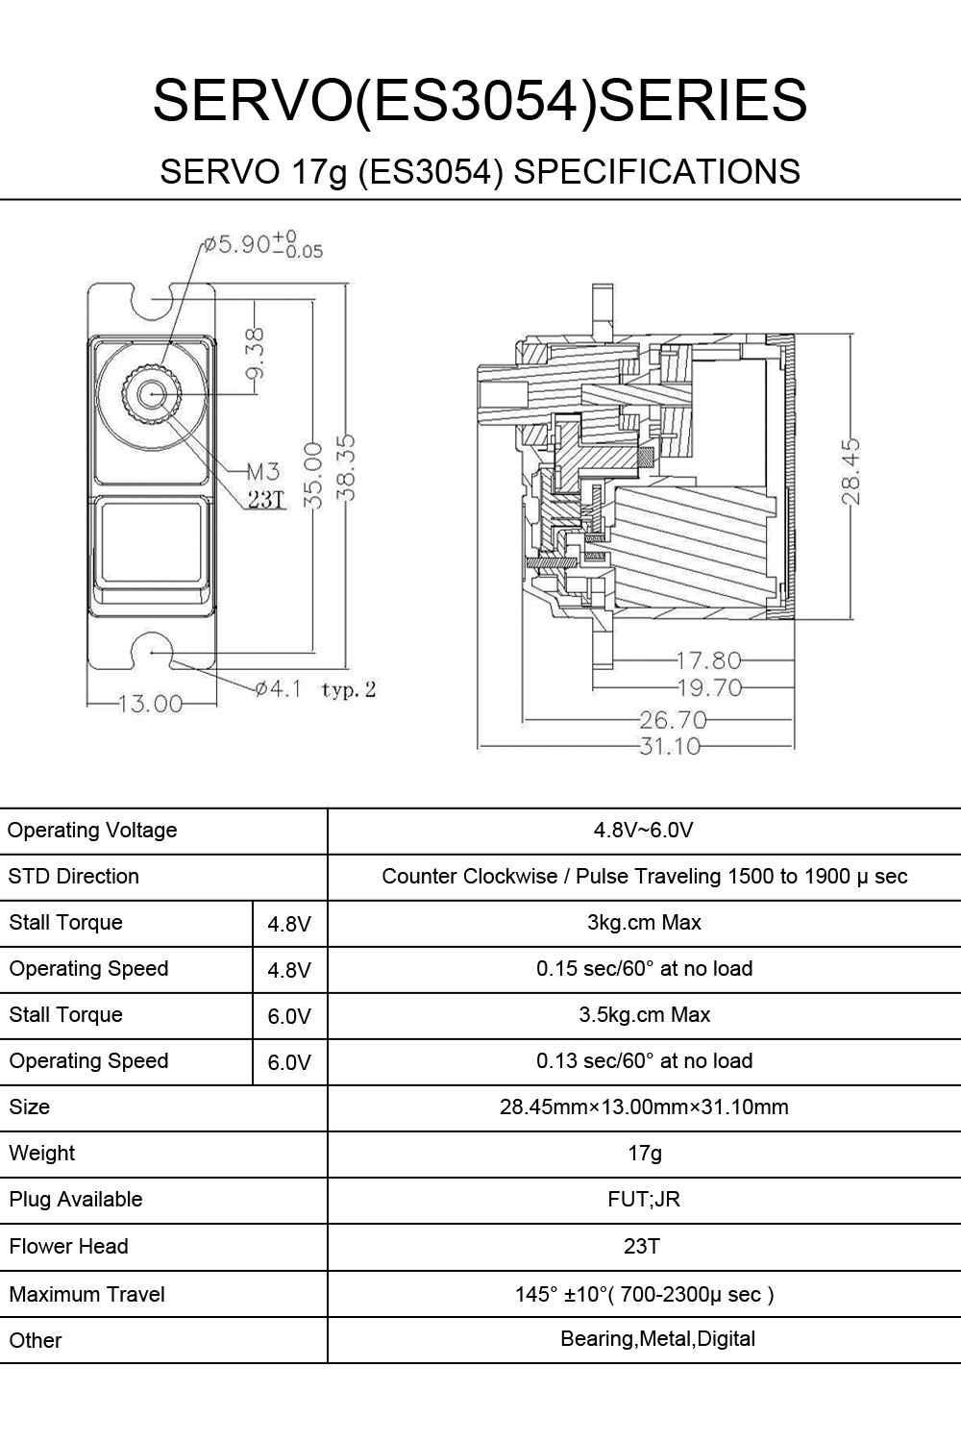
* Specifications:

|  |  |  |
| --- | --- | --- |
| Brand Name | | EMAX |
| Item Name | | ES3054 |
| Operating Voltage | | 4.8V - 6.0V |
| STD Direction | | Counter Clockwise / Pulse Traveling 1500 to 1900 μ sec |
| Stall Torque | 4.8V | 3kg.cm Max |
| Operating Speed | 4.8V | 0.15 sec/60° at no load |
| Stall Torque | 6.0V | 3.5kg.cm Max |
| Operating Speed | 6.0V | 0.13 sec/60° at no load |
| Size | | 28.45x13.00x31.10mm |
| Weight | | 17g |
| Plug Available | | FUT;JR |
| Flower Head | | 23T |
| Maximum Travel | | 145°±10° (700-2300μ sec) |
| Others | | Bearing; Metal; Digital |

* Package Included:  
  1x EMAX ES3054 17g Servo

Reasons for choosing this servo

* It has high torque
* Speed of rotation Is sufficient for our plane
* Produces over 300 pulses in a second
* This servo is a digital servo which is more sensitive to change in the transmitter stick values
* With this rapid pulse signals, the speed of the servo motor will increase significantly, and the torque will be more constant; it decreases the amount of deadband.
* Deadband is the amount of movement of the transmitter throttle stick from the centre to make the servo moving
* Also, with fewer deadband, the torque also provides a better holding capability. When you operate using a digital servo, you can experience the immediate feel of the control.

**transmitter**

**Spektrum DX18 transmitter**

## **KEY FEATURES**

* Dual antenna diversity
* Virtually unlimited model memory-transmitter stores up to 250 models and only populates the model list with models the user has configured
* Programmable and customizable voice alerts
* 18 fully-proportional channels
* Wireless trainer link
* Built-in telemetry with vibe or voice alerts
* Extensive airplane, helicopter and sailplane programming
* Throttle start or switch start timer
* Region settings for global compliance
* 16 programmable mixes
* 0.5% mix rate increments
* Origin mixing
* Flap delay and elevator compensation
* 11 airplane wing types
* 6 airplane tail types
* 2 canard options (1- and 2-servo) with elevon wing type
* 5 airplane and heli flight modes
* Dual rates and expo
* Active gyro trim
* 7-point heli throttle curve
* 7-point heli pitch curve
* 7-point heli tail curve
* 6 swashplate types
* Swashplate timing
* 2600mAh 2S LiPo transmitter battery
* Global charging system
* X-Plus™ technology expandability up to 18 channels
* 11ms frame rate
* Large LCD screen
* 5 menu languages: EN, DE, FR, IT and SP
* 2048 resolution on the first 10 channels
* Language selectable
* Includes AR9020 receiver
* EN328 compatible

## **PRODUCT SPECIFICATIONS**

# of Channels:18

Modulation:DSM2®/DSMX®

Band:2.4GHz

Receiver:AR9020

Programming Features:Airplane, Helicopter, and Sailplane

Model Memory:250

Modes:Selectable 1, 2, 3, or 4

Transmitter (Tx) Battery Type:2600mAh LiPo

Charger: Intl and Domestic Air Transmitter AC Adapter

Experience Level :Advanced

## **Receiver**

**AR10000 10Ch Rx**

## **KEY FEATURES**

* 10-channel full range receiver
* Patented MultiLink™ receiver technology
* Includes one internal and two remote receiver
* An optional third remote receiver can also be used (SPM9645)
* SmartSafe™ failsafe system
* QuickConnect™
* Flight Log and Telemetry compatible (optional)
* 2048 Resolution
* High-speed 11ms operation when used with capable transmitters

## **PRODUCT SPECIFICATIONS**

No of Channels:10

Modulation:DSM2, DSMX

Band:2.4GHz

Length:1.61 in (41mm)

Width:0.91 in (23mm)

Height:0.79 in (20mm)

Weight:0.42 oz (11.9g)

Voltage Range:3.5V-9.6V

## **OVERVIEW**

The AR10000 full range 10-channel receiver features DSM2™ and DSMX™ technology and is compatible with all Spektrum™ and JR® aircraft transmitters that support DSM2 and DSMX technology, including transmitters equipped with Spektrum DSM2 modules.

Always purchase products from a Horizon Hobby, Inc. authorized dealer to ensure authentic high-quality Spektrum product. Horizon Hobby, Inc. disclaims all support and warranty with regards, but not limited to, compatibility and performance of counterfeit products or products claiming compatibility with DSM2, DSMX or Spektrum.

The Spektrum™ AirWare™ software that comes in the DX18 offers all the programming features an expert pilot could want. And the intuitive SimpleScroll™ interface makes navigating menus and changing settings as simple as "roll and click." It's almost like using a mouse.  
  
Many Spektrum AirWare features are innovations you won't find anywhere else; innovations that make flying safer and programming easier.  
  
**Programmable Voice Alerts**  
With voice alerts, you can keep tabs on important functions without ever taking your eyes off what you’re flying. They can be programmed to call out what flight mode you’ve chosen or report telemetry information on demand. If an alarm goes off, you won’t have to look at the transmitter display to see what’s happening. The transmitter will tell you.  
  
**Pro-Class Programming for Sailplanes**  
In addition to extensive airplane and heli programming, the DX18 has the most impressive sailplane programming features you'll find in any handheld transmitter. Ten available flight modes, 5 wing types, 3 tail types, 2 motor types, flap delay with elevator compensation-it has it all. You even have the ability to adjust individual servo characteristics (end points, travel, center, etc.) for all 18 channels.  
  
**Built-In Sequencer**Program a sequence of switch-activated events with time delays between each event. For instance, with a flip of the gear switch you could have an auxiliary channel open landing gear doors, then have the retract channel lower the landing gear, followed by the auxiliary channel closing the gear doors after the gear is extended.  
  
**Built-In Servo Balancer**  
No more will you need a complicated network of little boxes littering your fuselage if you want to balance servos. You can precisely balance the output of swashplate servos or multiple servos on a single control surface with the transmitter using a 7-point curve mix.  
  
**Wireless Trainer Link**  
The wireless trainer link gives instructors the option to wirelessly "buddy box" with another DSM2®†/DSMX® transmitter. Once bound to another transmitter, ModelMatch™ technology will allow the DX18 to re-link without having to go through the bind process again.  
  
**250-Model Memory**  
The enormous capacity of the DX18's on-board memory means you will rarely, if ever, need to juggle models between transmitter memory and your SD card. The model memory menu is easier to navigate too. Only memory slots with model settings saved to them will appear. You won't have to scroll through empty slots or move models around if one is deleted.  
  
Because the DX18 Gen 2 uses the same software platform as the DX6 Gen 2, DX7 Gen 2 and DX9, you can share model setups with owners of those transmitters as well.

Comparison between edf motors

The motor that has been choosen for our plane is DS-51-DIA HST® (93mm).

**DS-51-DIA HST ® with DSM4335-950**

Let us now compare it with a motor of higher kv rating **DS-51-DIA HST ® with DSM4341-1050**

**DS-51-DIA HST ® with DSM4341-1050**

Inner jacket diameter: 93 mm  
Geometric throughput area: 51 cm²  
Total weight: 640 g  
Stand thrust range: 53-76 N  
Beam speed: 93-111 m / s  
Speed ​​range: 33,100-39,400  
Input power: 3.5-6.0 kW  
Battery: 10-12S 6000 mAh  
Efficiency: 70-71 %

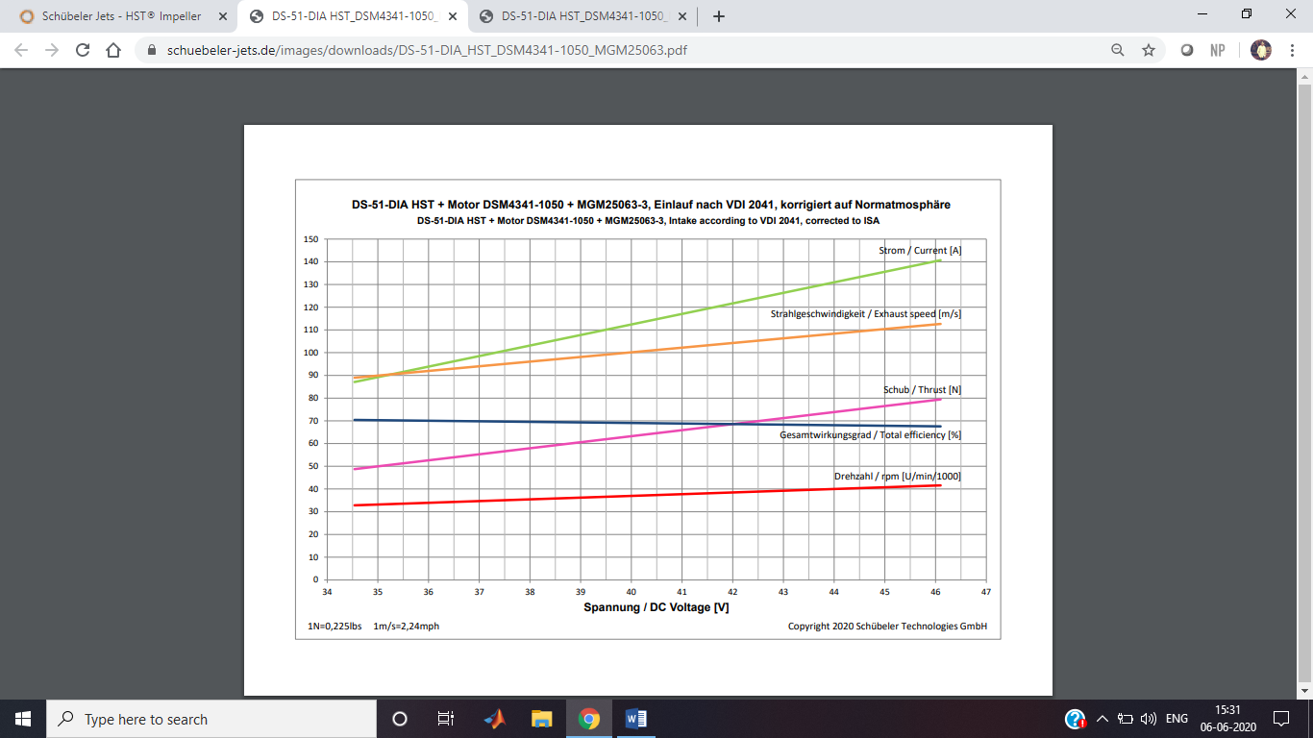

Main reasons for choosing **DS-51-DIA HST ® with DSM4335-950 over   
DS-51-DIA HST ® with DSM4341-1050**

* **The max current drawn by DSM4335-950 is 110A AND min current is 70A**

**Where as in DS-51-DIA HST ® with DSM4341-1050 the max current drawn 140A and min current drawn is 90A**

* **DS-51-DIA HST ® with DSM4335-950 has** Stand thrust range : 41-59 N which is sufficient for the design of our plane
* **Choosing DS-51-DIA HST ® with DSM4341-1050 which is heavier would lead to the choice of a battery with higher capacity and discharge rate and also the size of the battery chosen would increase .Since four such batteries are to be chosen .this would lead In reduction of the total number of balls carried as the size of the plane cannot be increase further**

**Let us compare it with** **DS-82-DIA HST with DSM6029-600**

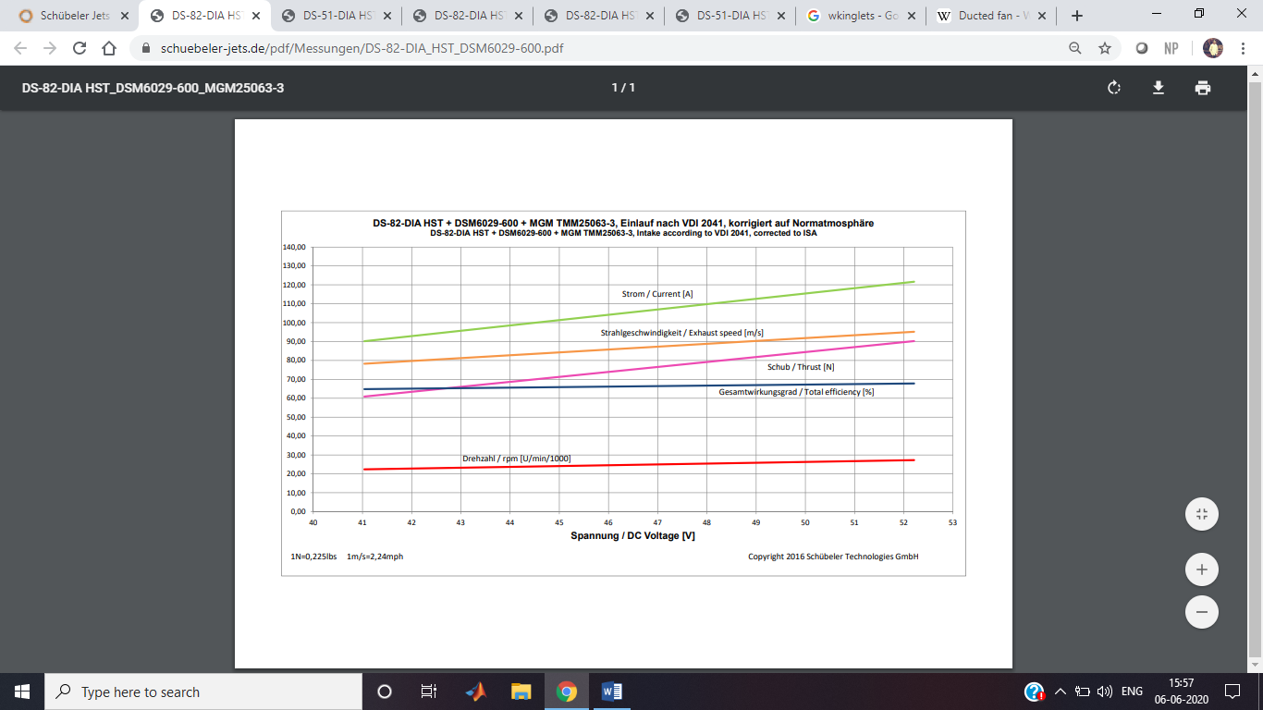

**Main reasons not choosing DS-82-DIA HST with DSM6029-600**

* **This motor less effiecent than DS-51-DIA HST ® with DSM4335-950**
* **This motor draws in a same amount of current it produces same rpm**
* **The space occupied is more compared to the motor chosen by us**
* **This motor is more expensive than the one we choose .**
* **This motor is also heavier**

**Reasons for choosing an electric ducted fan over bldc motor with a unducted propeller**

* By reducing propeller blade tip losses, the ducted fan is more efficient in producing thrust than a conventional propeller of similar diameter, especially at low speed and high static thrust level (airships, hovercraft).
* By sizing the ductwork appropriately, the designer can adjust the fan to allow it to operate more efficiently at higher air speeds than a propeller would.
* For the same static thrust, a ducted fan has a smaller diameter than a free propeller, allowing for smaller equipment.
* Ducted fans are quieter than propellers: they shield the blade noise, and reduce the tip speed and intensity of the tip vortices both of which contribute to noise production.
* Ducted fans can allow for a limited amount of thrust vectoring, something normal propellers are not well suited for. This allows them to be used instead of tiltrotors in some applications.
* Ducted fans offer enhanced safety on the ground

